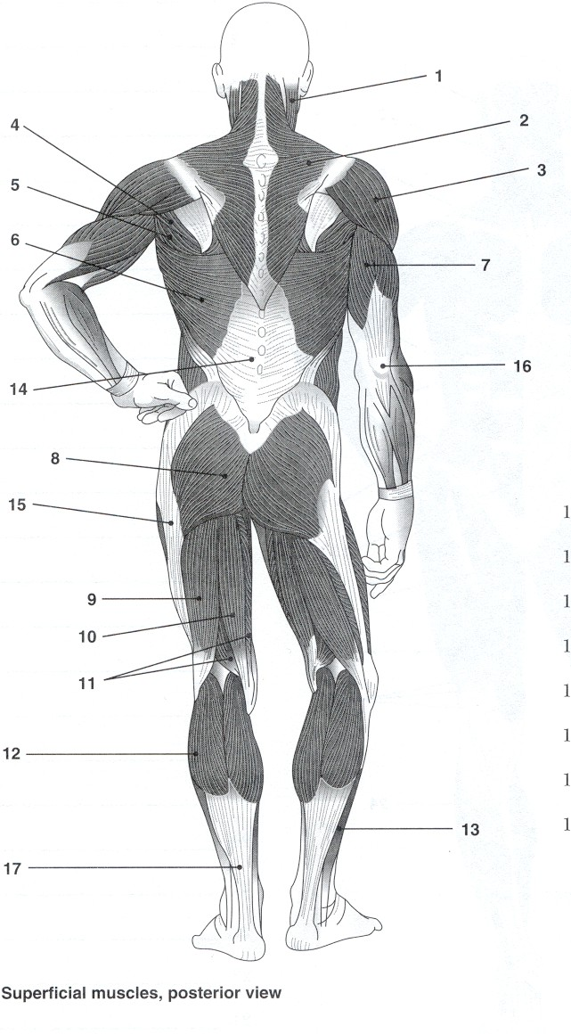
Superficial Posterior Muscles Review!

